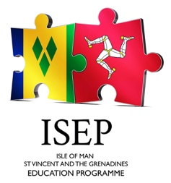

IOM-SVG Education Programme
A charity registered in the Isle of Man, Number 1336

Donation Form

ISEP embodies “The Art of the Possible” by seeking to inspire and transform the lives of young people from St Vincent and the Grenadines by providing scholarships and travel grants for students to study in the Isle of Man.

Donor Information
Name (Individual, Business, or Foundation/Charity)

Street Address | Email
City, Postal Code | Mobile Phone
Signature of Donor | Alternate Phone

Donation Description
Tick one Single financial contribution Monthly or annual donation Other (e.g. Contribution in kind)
AMOUNT / DESCRIPTION | DATE
- Pay by bank transfer to Lloyds Bank:
Account name: IOM-SVG Education Programme Account number: 48034260 Sort Code: 30-12-80
BIC: LOYDIMD1001 IBAN: GB42 LOYD 3012 8048 0342 60

- Or send a cheque (Payable to ISEP) to the address shown below.

Your donation(s) will be used solely for the purposes of the charity (scholarships, student flights, study programme, student uniforms, books, exam fees, and other items of direct benefit to students). ISEP relies on volunteers to run the charity who also provide funds to cover administrative costs.

Contact Information
ISEP (Registered office)  5 The Crescent, Derbyhaven  Isle of Man, IM9 1TX, British Isles  www.isep.im | Contact Name  Tim Cullen, Chairman  Mobile: +44 (0) 7979 597767  Email: elaine.moretta@isep.im

